Formatting Instructions - MS Word

Title: in Bold Characters and Centered
A.B. Lastname¹, C.D. SecondAuthor^{1,2}, E.F. ThirdAuthor²
¹University of Applied Science Rapperswil, Rapperswil, Switzerland.
²Université de Technologie de Compiègne, Compiègne, France.
The following abstract is already formatted: you can use it as reference to write your own abstract: Title, authors, affiliation, references, margins, paragraphs and line spacing are correctly defined.
The page size should be DIN A4 (21.0 x 29.7 cm).,with a 2.5 cm margin all around. The font should be Times New Roman 12 pt. Line spacing should be 1.5 lines. All paragraphs should be justified. The abstract should include: Title, Authors' Names (Only Initials, followed by last name), Authors' Affiliations, Abstract Text and References. The distance between each paragraph should be defined as indicated in the Figure below: Spacing before = 12 pt, after = 12 pt, line spacing = 1.5lines.
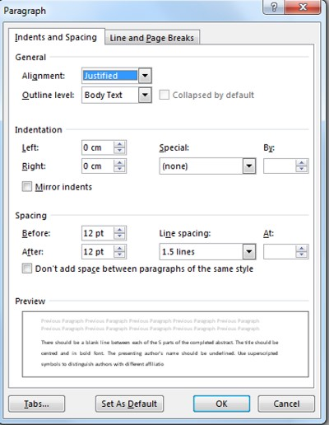
Please, try to include a picture or a diagram summing up your main topics or results.
There should be a blank line between each parts of the completed abstract. The title should be centred and in bold font. The presenting author's name should be underlined. Use superscripted symbols to distinguish authors with different affiliations. Start each affiliation on a new line, starting with the identifying symbol if there are multiple affiliations.
The abstract should be maximum two pages and minimum one page long. If necessary, indicate references with sequential numbers within [square brackets]. The references should be written as indicated below. First the authors' names. Second, the standard abbreviation for the journal, volume number, starting page number followed by the year in brackets. In case of a book, the book's title would replace the journal title, followed by the volume, page, and editor's name, location, and the year in [brackets].
[1] P. Jousset, M. Rachik, J. Adhesion Sci. Technol., 24, 1995 (2010)
[2] L. F. M. da Silva, D.A. Dillard, B. Blackman, R.D. Adams, Testing Adhesive Joints: Best Practices, p.468, Wiley VCH, 2012

